**PROJECT 1: VPC peering**

SS1: VPCs list

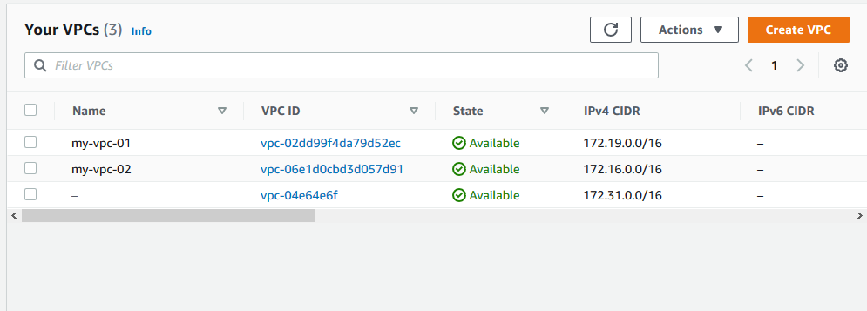

Ss2: igw list

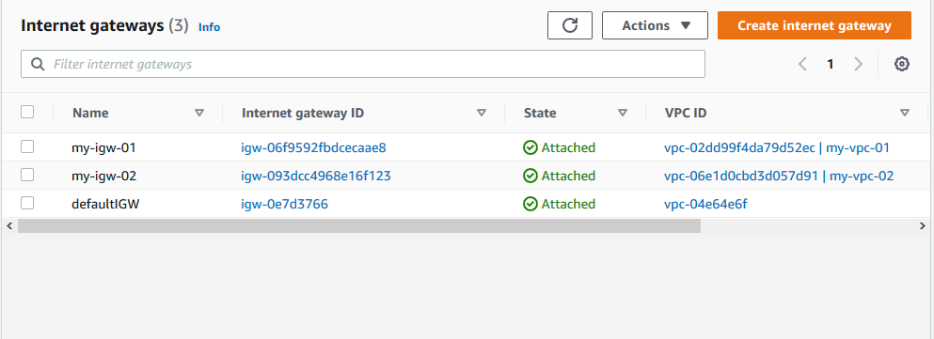

Ss3: Route list

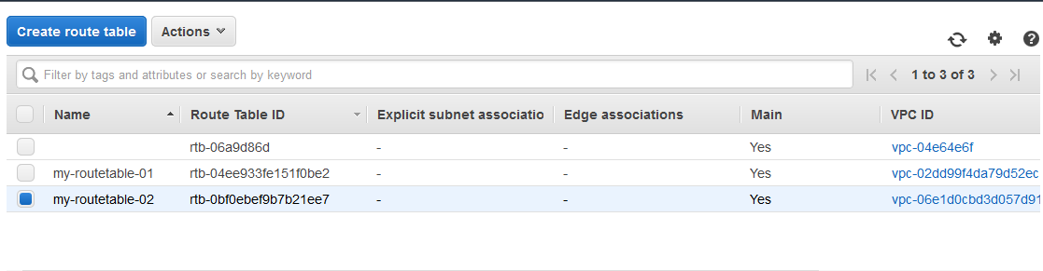

Ss4: Subnet list

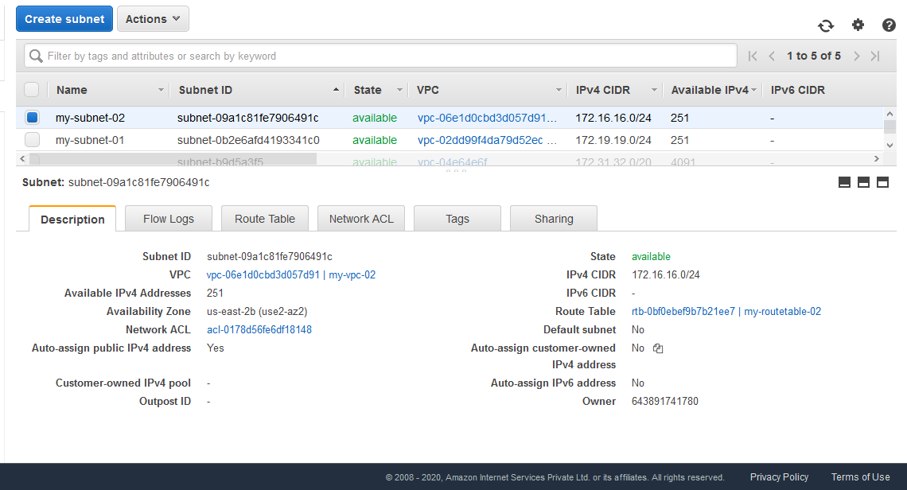

Ss5: instance details

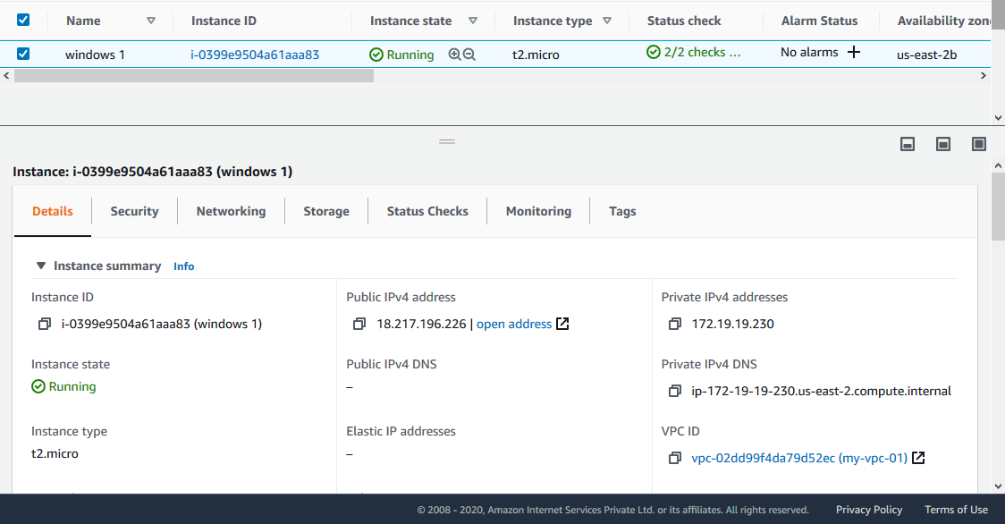

Windows instance first

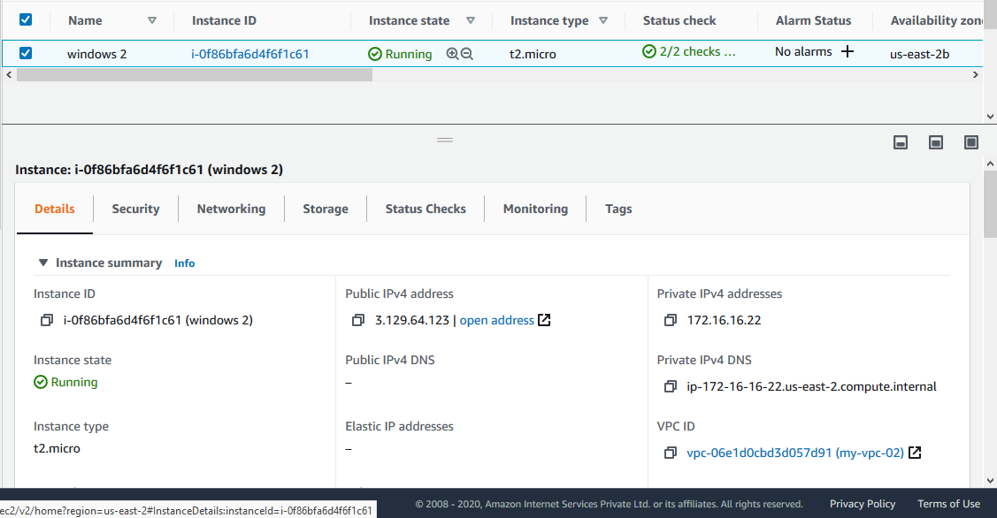

Windows instance second

Ss6: success public ip ping from host machine

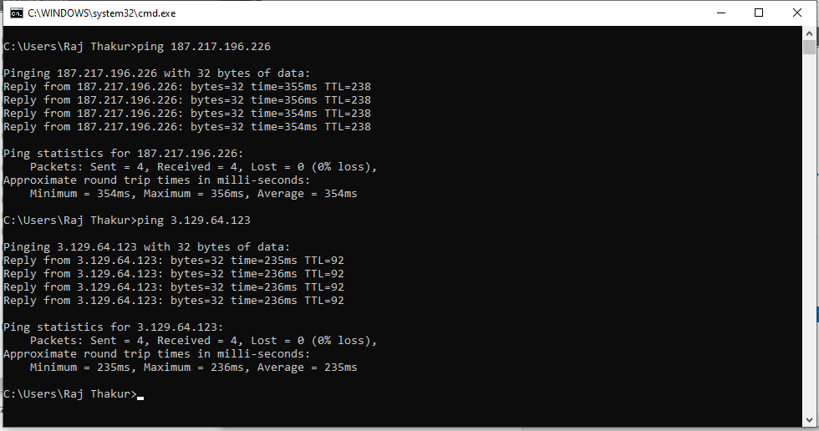

Ss7: peering with req and acceptor

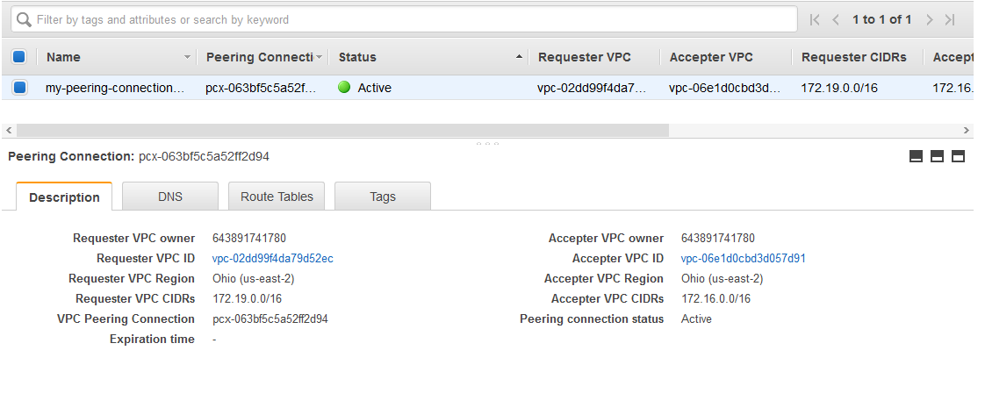

Ss8: success for private ip ping from one machine to another

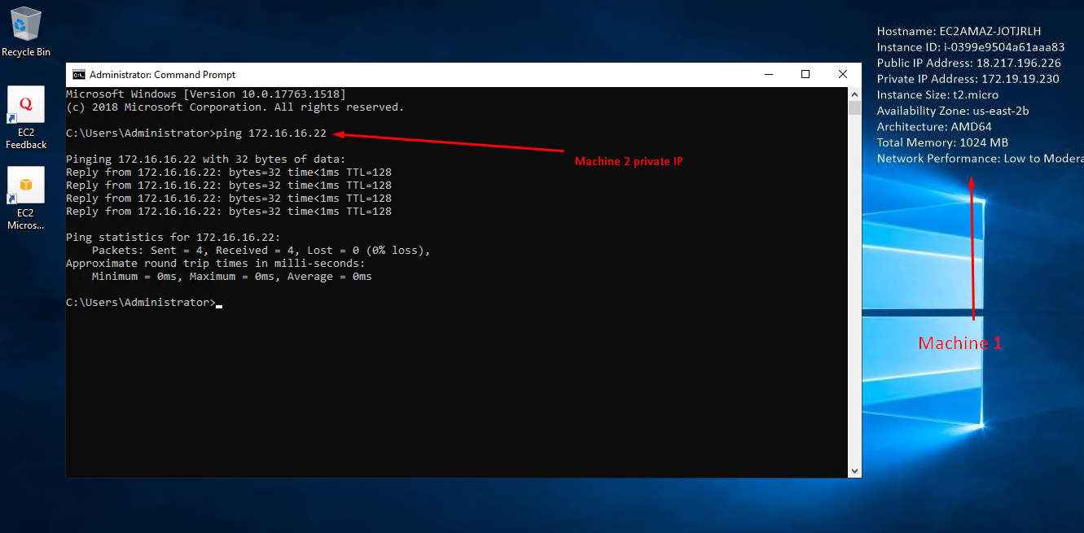

**Project 2: IAM**

Task 1:Creating users **with** permissions-IAM password policy check.

Ss1: user summary with all tab information

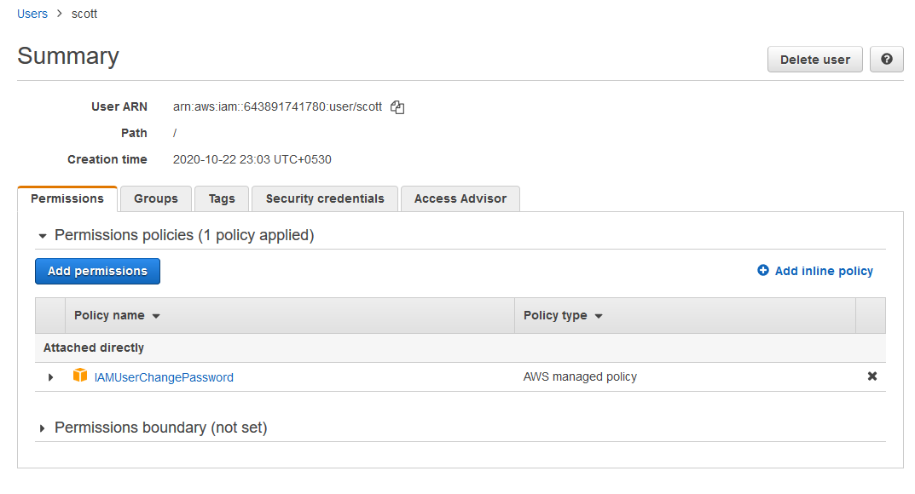

Task 2:Creating users **without** the IAM password policy.

Ss2: user summary with all tab information

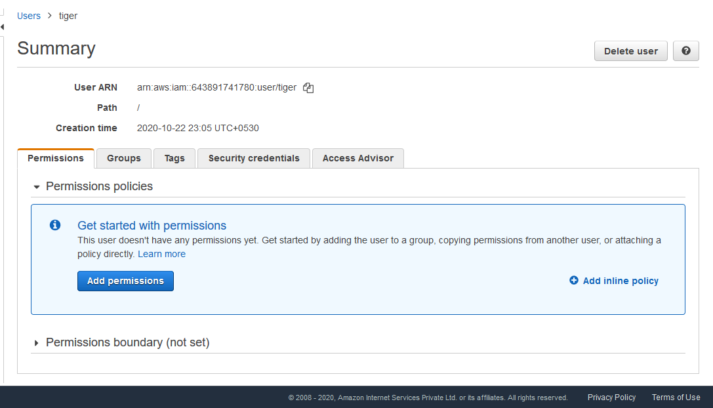

Task 3:Create a user with S3 full access

Ss3: User summary

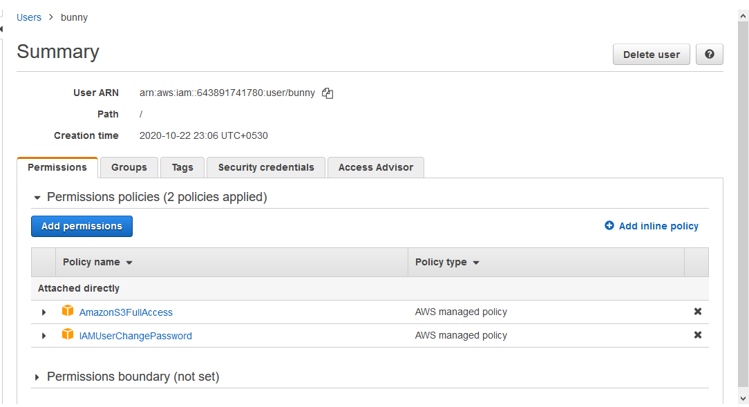

Task4: Create a group with ec2 full access

Ss4: group summary

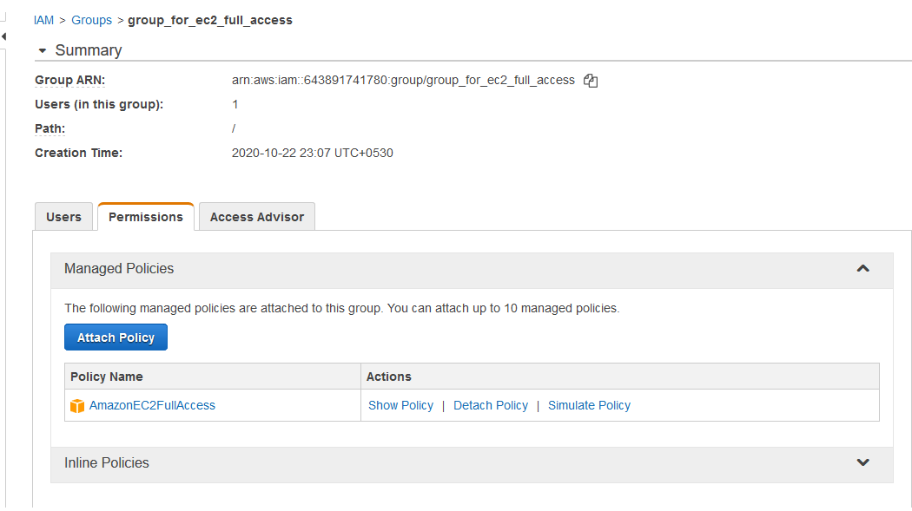

Task 5:Add user to a group and check if user policy and the group policy is reflecting on the user

Ss5: user summary with permissions

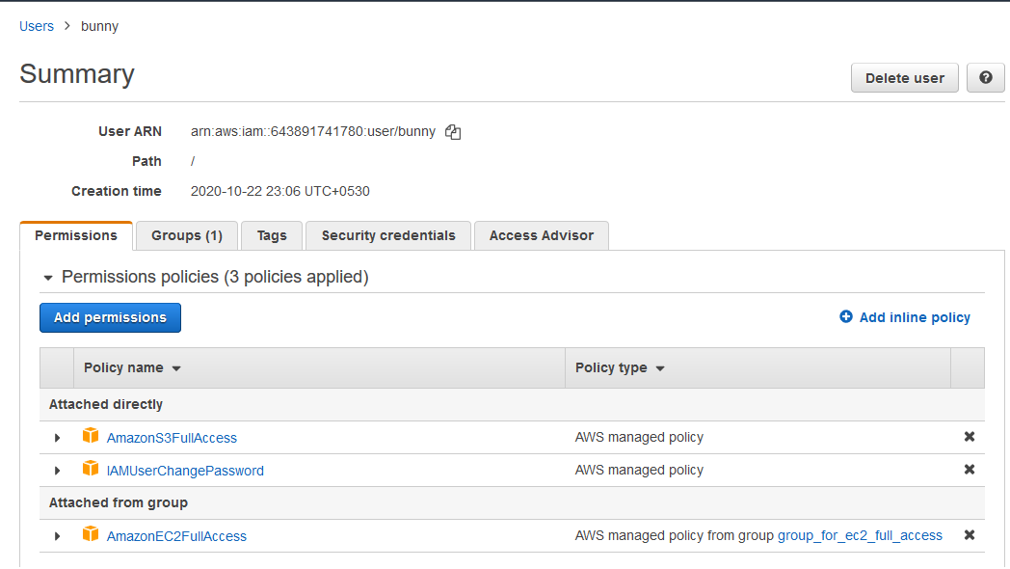

Ss6: login as this user show that this policy is in effect

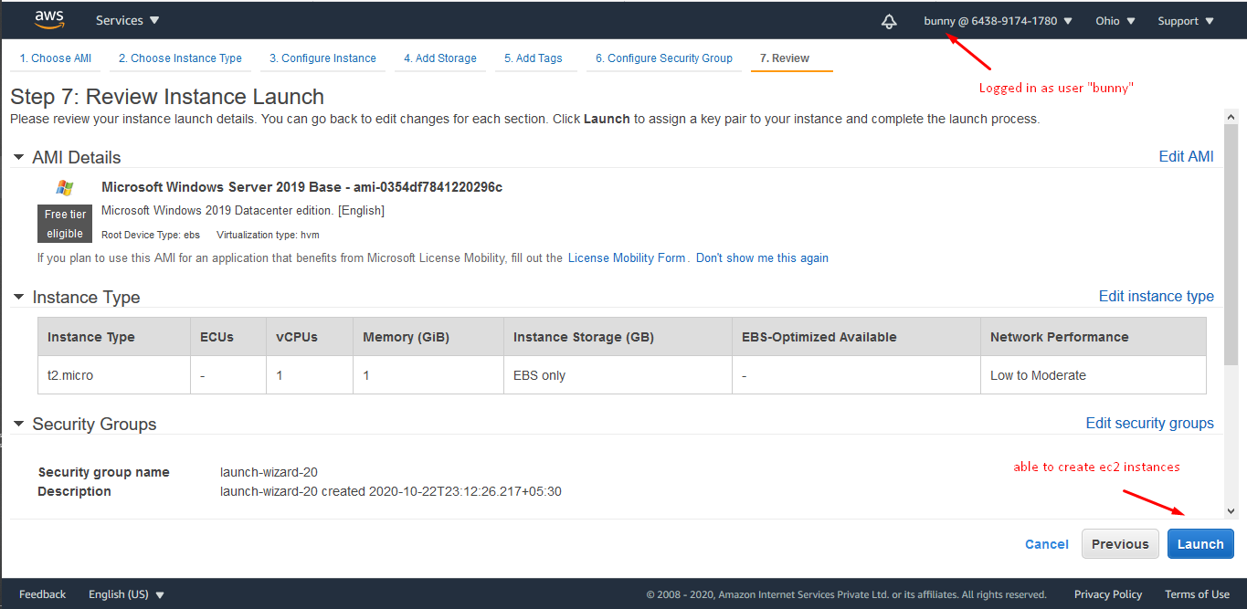

Task 6:Copy policies from the existing user

Ss7: attach user summary of the user from which you create a new user

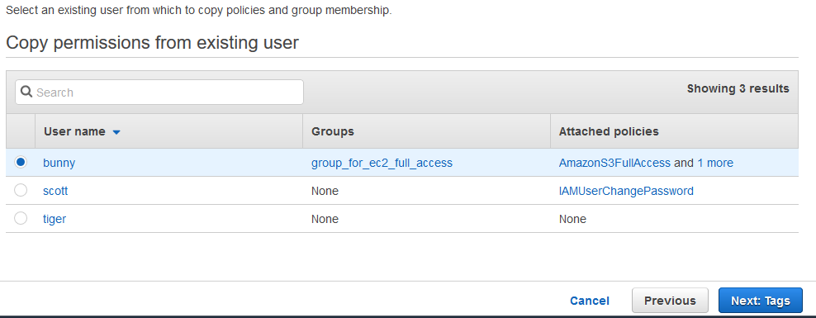

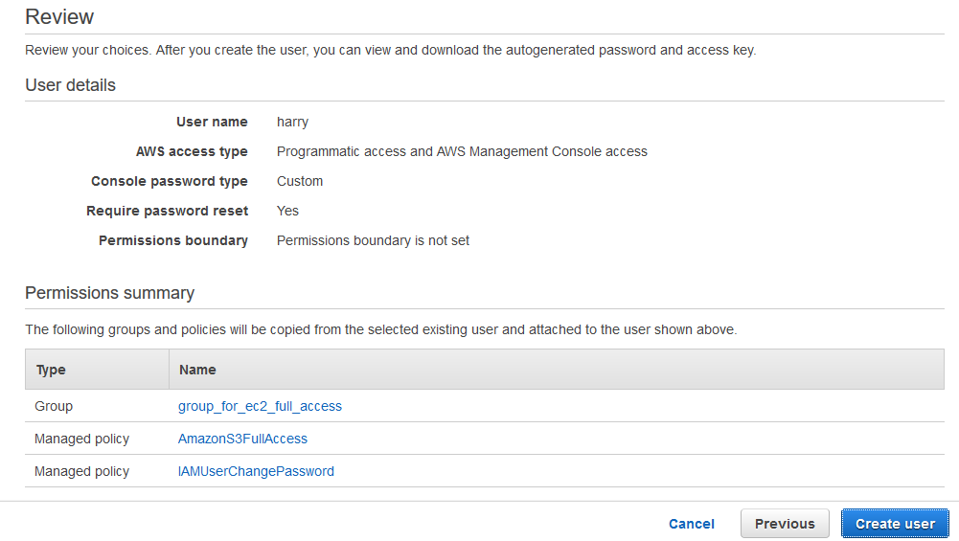

Ss8: login as this user show that this policy is in effect

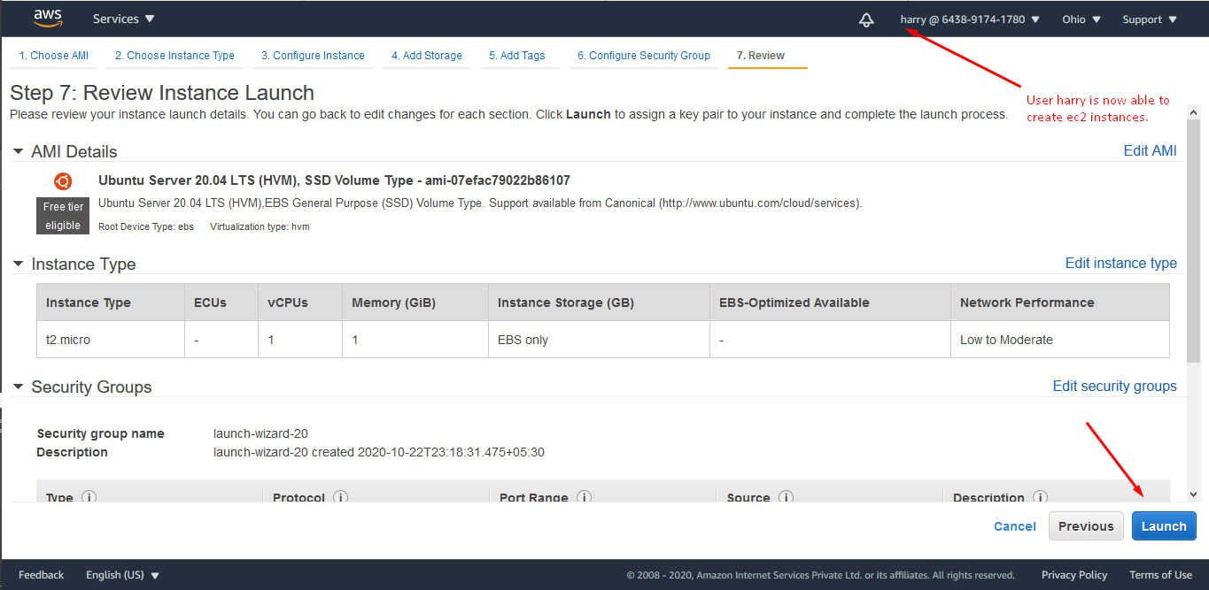

Task 7:Add user to a group in the process of creating a user : Same as above attached screenshots.

Task8: setting a password policy

Ss9: password policy screen

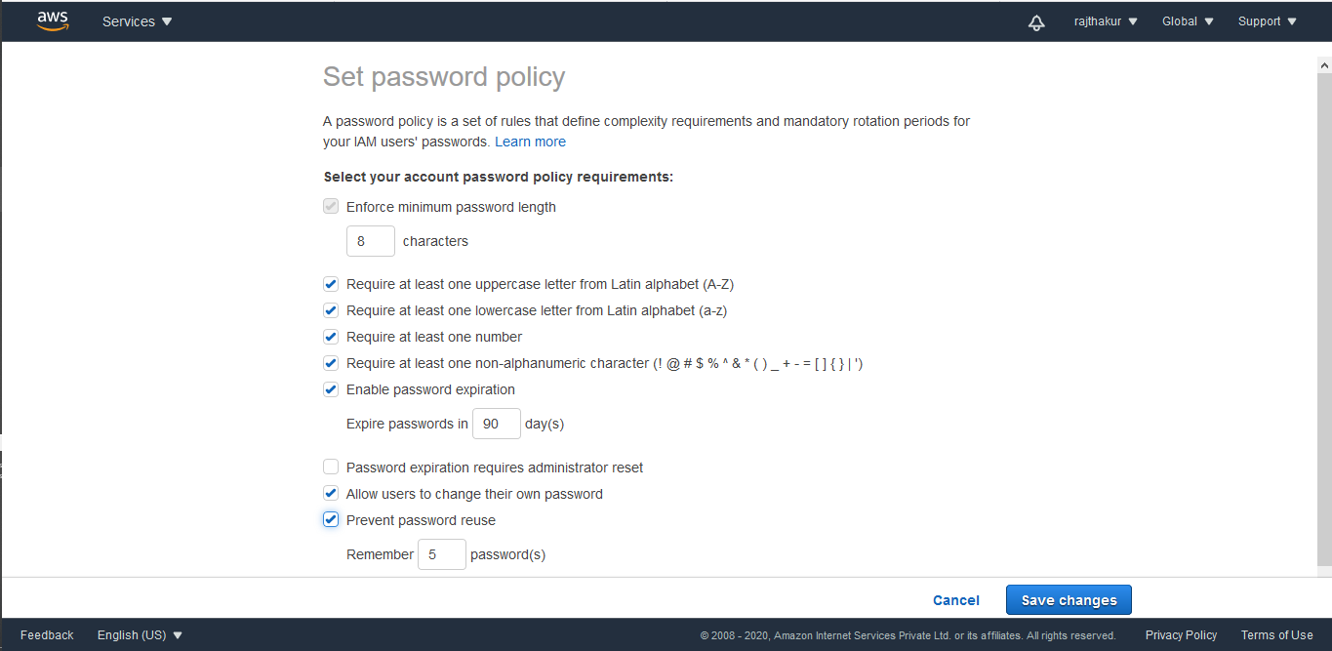

Ss10: login as the user and show password incompatibility error

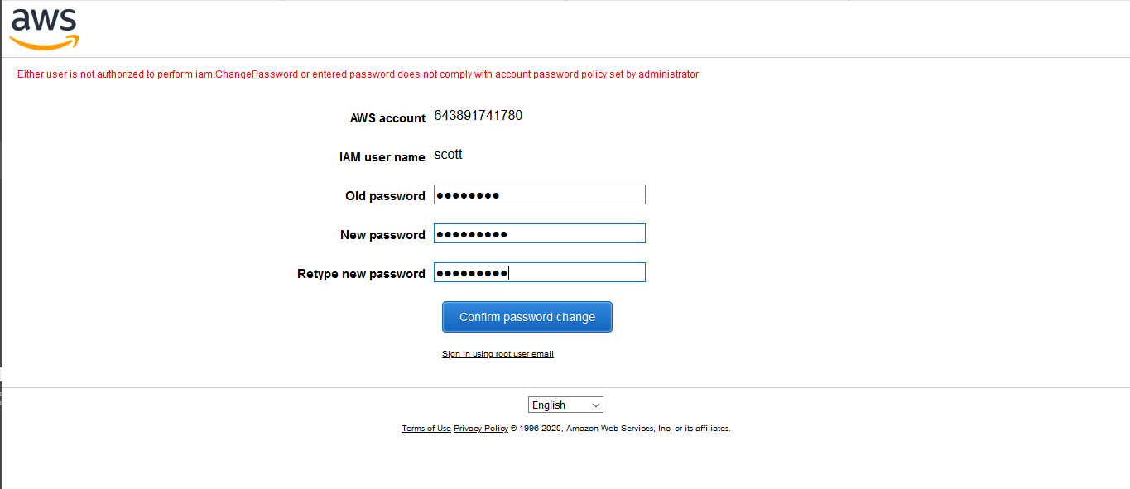

Task 9:Enabling MFA and using an MFA device

Ss11: enable MFA

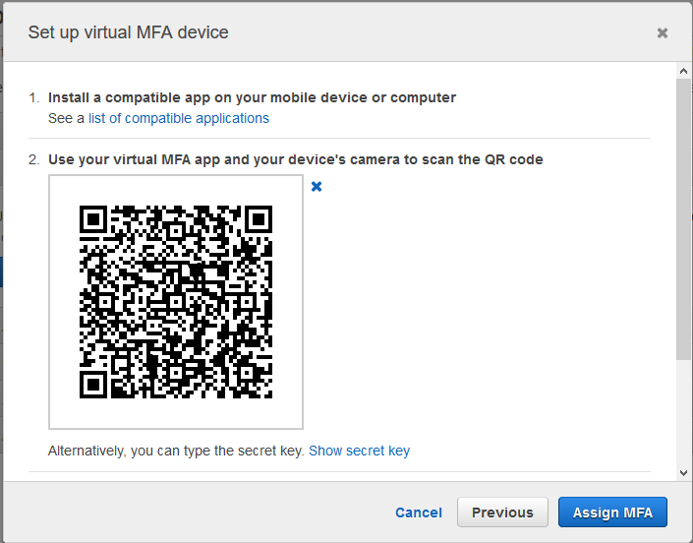

Ss12: login screen for MFA

